Program 1
/*Program to print the following pattern:
@
@@
@@@
@@@@
@@@@@*/

#include <stdio.h>
int main()
{
for (int i = 1; i <= 5; i++)
{
for (int j = 1; j <= i; j++)
{
printf("@");
}
printf("\n");
}
printf("\n");
}

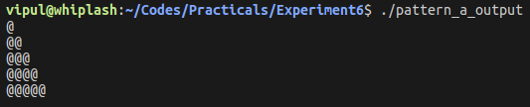
Program 2
/*Program to print the following pattern:
1
1 2
1 2 3
1 2 3 4
1 2 3 4 5*/

#include <stdio.h>
int main()
{
for (int i = 1; i <= 5; i++)
{
for (int j = 1; j <= i; j++)
{
printf("%d ", j);
}
printf("\n");
}
printf("\n");
}

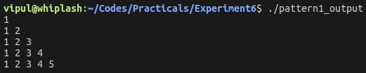
Program 3
/*Program to print the following pattern:
1
2 3
4 5 6
7 7 9 10
11 12 13 14 15*/

#include <stdio.h>
int main()
{
for (int i = 1, k = 1; i <= 5; i++)
{
for (int j = 1; j <= i; j++)
{
printf("%d ", k);
k++;
}
printf("\n");
}
printf("\n");
}

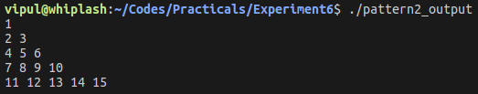
Program 4
//Program to design a calculator using switch case

#include <stdio.h>
int main()
{
float a, b, res;
char opt;
printf("Enter 2 numbers:\n");
scanf("%f %f", &a, &b);
printf("\nEnter operator:\n");
scanf("%c %c", &opt, &opt);
switch (opt)
{
case '+':
res = a + b;
break;
case '-':
res = a - b;
break;
case '*':
res = a * b;
break;
case '/':
res = a / b;
break;
default:
printf("\nEnter valid operators only\n");
}
printf("\nThe result = %f\n\n", res);
}

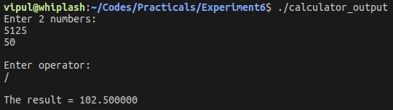
Program 5
//Write a menu driven program to print days of week using switch case

#include <stdio.h>
int main()
{
int day;
printf("Enter day of week i.e. 1:\n");
scanf("%d", &day);
switch (day)
{
case 1:
printf("\nDay %d is Monday\n", day);
break;
case 2:
printf("\nDay %d is Tuesday\n", day);
break;
case 3:
printf("\nDay %d is Wednesday\n", day);
break;
case 4:
printf("\nDay %d is Thursday\n", day);
break;
case 5:
printf("\nDay %d is Friday\n", day);
break;
case 6:
printf("\nDay %d is Saturday\n", day);
break;
case 7:
printf("\nDay %d is Sunday\n", day);
break;
default:
printf("\nEnter a valid day of the week(number)");
break;
}
printf("\n");
}

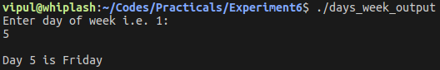
Program 6
//Write a menu driven program to print month of the year based on the number entered by user

#include <stdio.h>
int main()
{
int Month;
printf("Enter month number:\n");
scanf("%d", &Month);
switch (Month)

case 1: printf("\nMonth %d is January\n", Month);
break;
case 2: printf("\nMonth %d is February\n", Month);
break;
case 3: printf("\nMonth %d is March\n", Month);
break;
case 4: printf("\nMonth %d is April\n", Month);
break;
case 5: printf("\nMonth %d is May\n", Month);
break;
case 6: printf("\nMonth %d is June\n", Month);
break;
case 7: printf("\nMonth %d is July\n", Month);
break;
case 8: printf("\nMonth %d is August\n", Month);
break;
case 9: printf("\nMonth %d is September\n", Month);
break;
case 10: printf("\nMonth %d is October\n", Month);
break;
case 11: printf("\nMonth %d is November\n", Month);
break;
case 12: printf("\nMonth %d is December\n", Month);
break;
default: printf("\nEnter a valid Month of the Year(number)");
break;
}
printf("\n");

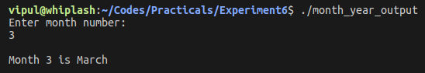
Program 7
/*Program to print the following pattern:
*
***
*****
*******
********* */

#include <stdio.h>
int main()
{
for (int i = 1; i <= 5; i++)
{
for (int j = 5 - i; j > 0; j--)
printf(" ");
for (int k = 1; k < 2 * i; k++)
printf("*");
printf("\n");
}
printf("\n");
}

